Geography: Where is Rwanda?
Using the QR provided shade in Rwanda on the map of Africa. Add the capital city to the blank map of Rwanda.
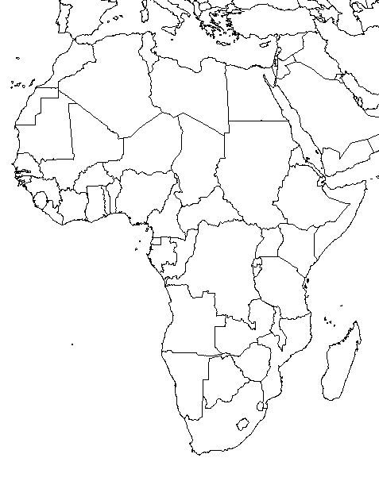
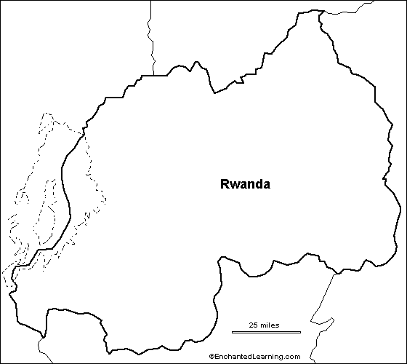
The Division Begins
In the 18th century, the division between the Hutus and Tutsis began. Use the information provided to complete the chart below showing the differences between the two groups living in Rwanda.

Hutu | Tutsi

Colonialism in Rwanda
After World War I, Germany lost control over Rwanda and it was given to the Belgians. Use the information provided about Belgian rule in Rwanda to answer the following questions in complete sentences.

- For what reason did the Germans and Belgians favor the Tutsis during their colonial rule of Rwanda?

- What physical features were used to determine a person’s classification in Rwanda?

- What restrictions led to increased Hutu resentment by the 1950’s?

- What resentment did the Tutsis have?

Identification Cards
Use the information provided about the identification cards to provide a paragraph(4-7 sentences) response to the question below.

- Do you think the system of identification cards instituted by the Belgians in Rwanda was a fair and effective system? Explain.

Rwandan Genocide
Use the information sheet about the genocide in Rwanda to answer the questions below.

- What event started the mass killing of Tutsis in Rwanda?

- How many people were slaughtered during the three month period of the genocide?

- After the RPF had gained control over Rwanda in July 1994, why do you think so many Hutus began fleeing the country?

- How did the RPF make sure that both groups were represented in the newly formed government of Rwanda?

- What is your reaction to the photographs shown in the information sheet?

