Boers of South Africa

Who were the Boers?
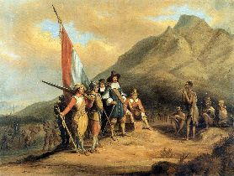
Jan van Riebeeck by Charles Bell The first European colony established in South Africa was Cape Town, which was founded in 1653 by Dutchman Jan van Riebeek. As this colony grew, more Dutch settlers whose families had lived there for centuries became known as the Boers.

British Rule
In the early 1800s, the British began to take control of the region. Although the Boers fought back, the Netherlands gave up control of the colony to Britain in 1814 as part the Congress of Vienna. Soon, thousands of British colonists arrived in South Africa. They made many changes to the laws and ways of life for the Boers.

Great Trek
The Boers were unhappy under British rule. They decided to leave Cape Town and establish a new colony. Starting in 1835, thousands of Boers began a mass migration to new lands to the north and east in South Africa. They established their own free states, called Boer republics, including the Transvaal and the Orange Free State. These people were nicknamed the "Voortrekkers."

First Boer War (1880 - 1881)
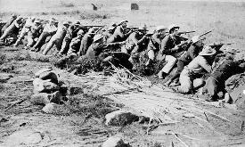
In 1868, diamonds were discovered on Boer lands. This caused an influx of new settlers into the Boer territory, including many British. The British decided that they wanted to control the Transvaal and annexed it as part of the British colony in 1877. This did not sit well with the Boers. In 1880, the Boers of the Transvaal revolted against the British in what became known as the First Boer War. The skill and tactics of the Boer soldiers took the British by surprise. They were very good marksmen. They would attack from a distance and then retreat if the British soldiers got too close. The war ended with a Boer victory. The British agreed to recognize the Transvaal and the Orange Free State as independent states.

Second Boer War (1889 - 1902)
In 1886, gold was discovered in the Transvaal. This new wealth potentially made the Transvaal very powerful. The British became concerned that the Boers would take over all of South Africa. In 1889, the Second Boer War began. The British had thought that the war would last only a few months. However, the Boers once again proved to be tough fighters. After several years of war, the British finally defeated the Boers. Both the Orange Free State and the Transvaal became part of the British Empire.

Concentration Camps
During the Second Boer War, the British used concentration camps to house Boer women and children as they took over territory. The conditions in these camps were very bad. As many as 28,000 Boer women and children died in these camps. The use of these camps was later used to stir up resistance against British rule.

Interesting Facts about the Boers of Africa
- The word "boer" means "farmer" in Dutch.
- The Boers were part of a larger group of white South Africans called Afrikaners.
- Other nations were part of the Second Boer War. Australia and India fought on the side of the British, while Germany, Sweden, and the Netherlands fought on the side of the Boers.
- Many of the Boers left South Africa after the Second Boer War. They went to places like Argentina, Kenya, Mexico, and the United States.
- The Boers attempted to revolt against the British at the start of World War I. This was called the Maritz Rebellion.

