Age of Revolutions Project
Directions: Pick one project activity to complete from the list below. Your project will focus on one of the following revolutions: American Revolution, French Revolution, Latin American Revolution and Industrial Revolution.

Project  Options: | Illustrated Children’s Book  Write and illustrate a children’s book explaining events or ideas from one of the revolutions. Must be at least 20 pages. Pages must include a color illustration(must be drawn) and typed text(2-3 sentences per page). | Journal  Assume the perspective of an ordinary citizen of one of the revolutions. Be mindful of the figure’s class status. You must create at least 10 journal entries that are a minimum of two paragraphs each.Finished product should look like an actual journal and must include ONE artifact tucked into the journal.
Music Video  Create a “History Teachers”-type music video teaching the class about one of the revolutions. Must include visuals and be around 3 minutes long.(Must be recorded at home). You must submit a copy of your lyrics along with the video.You must upload to YouTube and send me the link. | Model  Create a model of an event, movement or idea from one of the revolutions. It must be three-dimensional and include a one-page explanation of how the event impacted a particular revolution.  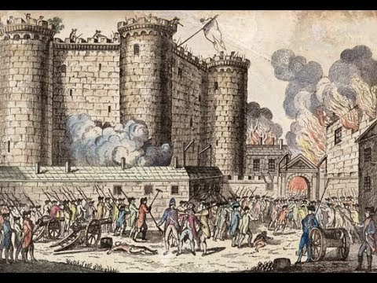 | Create Your Own Project  Must have teacher approval prior to the turn in day to ensure it meets difficulty level and content requirements! You need to explain in detail what this project will cover and the format you are presenting your information in. This needs to be turned into your teacher by ______________. If this option is missing rigor or details, it WILL NOT be approved. If you do this option without prior approval you will automatically lose a letter grade.

***DUE _______________________ – THIS WILL BE A FORMAL GRADE FOR THE SECOND QUARTER***

